The STORK
KEMH Alumni Inc Newsletter
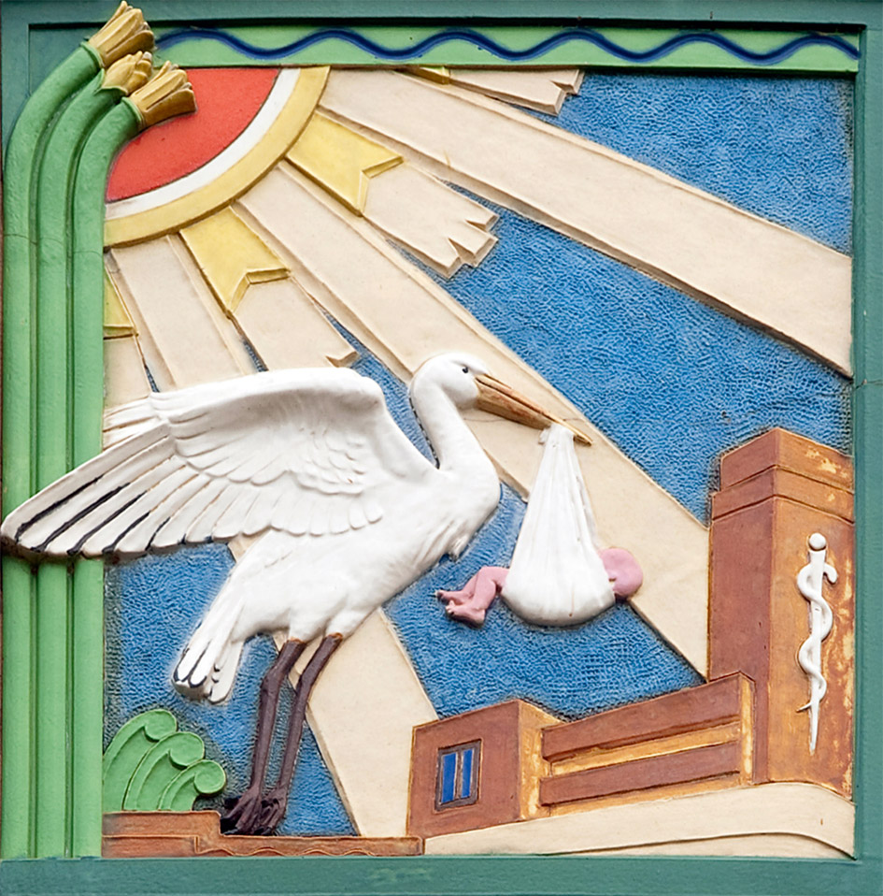
Issue No. 6 July 2021

Hello again! Not long since the last newsletter but there are a few things that it is important to share with you now.

KING EDDIES DAY – change of date

King Eddies Day was to have been on Tuesday morning, 6th July. This has now been changed to Tuesday 13th July, 9.30 – 11.30 in the Staff Dining Room. The alumni will be helping to mount a display showing some of KEMH’s history as well as giving out fresh cupcakes to staff. We will also be giving out information about the alumni.

NEXT SOCIAL EVENT

Thursday 15th July 2021 – refreshments from 6pm, presentation at 6.30pm.

Clinical Staff Lounge, Level 2, A Block KEMH (take lift in the front entrance to 2nd floor)

“The life and times of Edith Cowan – Fake News Included!” presented by Hilary Silbert.

The AGM will be conducted after the evening’s presentation.

ALUMNI EVENT 16th SEPTEMBER –
RSVP needed soon

A visit to Bentley Tafe restaurant The Pines is planned for Thursday 16th September, for lunch @ 11.30. The cost is $35 per head, but as a sizeable deposit is needed, we need to have your RSVP by 15th July at the latest. Send to KEMH.Alumni@outlook.com
Here is the menu for August – delicious and something for everyone to enjoy.

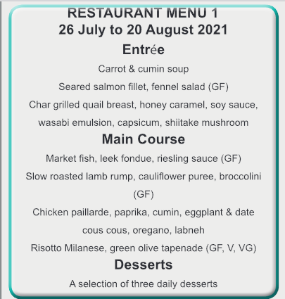

Vale Jill Thompson

Thank you, Graeme Boardley, for the following words celebrating Jills’ life and contribution to KEMH.
It is with sadness that I advise you of the passing of Jill Thompson, midwifery educator (retired 2002) and passionate women’s health advocate. Jill passed peacefully on June 15 with her two beloved sons by her side.
Many … will have worked with and been educated by Jill during her many years of dedication to KEMH and midwifery education in particular.
Jill was a life member of the ACM and was one of the five first Fellows of the College. She was the academic gold medallist in both nursing & midwifery-KEMH. Jill was the National Delegate for WA on the ACM for 6 years and worked tirelessly to promote midwifery continuity of care together with the rights of women to choose the birth that they wanted in the care of a midwife.
There will be many midwives still here at KEMH, throughout the state, in Australia and overseas who would remember Jill’s contribution to the midwifery profession. We should all celebrate and be thankful for her life, wise counsel, and support.
I personally remember and appreciate Jill’s kindness and support during my early midwifery career. She was a very kind woman above all else.
The following recollections are taken from the oral history recorded by Jill in 2015.
I started at King Edward, as a Midwifery Student in March of 1976. I It was quite interesting how I became a Midwifery Student because it was never my intention. In 1975 the Anglican Church was holding what was called the Celebration ’75 Picnic at Perry Lakes and people like Desmond Tutu and other bishop from Africa had been in Perth at that time and this was the grand finale.

Lo and behold at the picnic I bumped into a mentor from Royal Perth Hospital, Ms Rosalind Denny. Now, she had been very good to me at Royal Perth Hospital, she was the second ward sister that I encountered. She had extremely high standards and I believe was ahead of her time. The juniors, which I was, very junior having been in the hospital probably about 3-4 months at that stage were treated very well. She would actually give you your own patients, half a dozen patients and she taught me how to do injections, dressings, in fact, total patient care. Now, this was 1957, she was way ahead of her time because they didn’t have really clinical instructors at that time and she encouraged me. I formed a very good relationship with her.

I was married and then when I bumped into her at the picnic, or encountered her, she said “when you want to come and do midwifery, come and see me”. I thought “well, why would I want to come and do midwifery? Firstly, I was married to an Englishman who didn’t believe in women, working particularly his wife. At the time we were married, in fact, married women were not employed by the Government, so that meant if you were a teacher or a nurse you didn’t resign on marriage you just weren’t employed from that point onwards. It was only after I was married that the legislation was changed. I had two small children who were probably 6 and 8 at that time, maybe 7 and 9, and what’s more I had a slight paresis of my right side. I had about 3 years earlier had meningitis and encephalitis which left me with a hemiparesis and at the time in 1975 I was walking very well but I didn’t have the photographic memory that I had previously had and it was still quite difficult to write. She knew that but still she said `when you want to do midwifery, come and see me’.

Well, I had been wanting to do something, Murdoch University had opened, and I was thinking I’d like to be a student there, I’d like to study but the penny dropped that if I was a Midwifery Student, nobody would expect me to know anything. What I knew was that if I saw something and I had my notebook in my pocket that I would be OK. The memories would come back; I was having to draw those memories from the past into the present. Martyn wasn’t at all keen, but he did agree that I could have like a year off to go and do the midwifery course and Ros Denny actually came out and she had dinner with us. I remember her saying very clearly, “you know if you find yourself in a spot of bother, come and see me”.

Well, in fact when I really did find myself in a spot of bother having lost the person who was caring for the children when I wasn’t around, I couldn’t get an appointment with her, but that’s another story.

And so, that was how I came to be at King Edward, was not part of my plan, I had no burning desire to be a midwife, it was simply one way of getting back on track again. When I went to see her she explained that there were certain conditions that usually had to be met for anyone embarking on the midwifery course and how these had come about. Experience told her that it was very difficult to work and study at the same time, perhaps more so if you had other responsibilities and if you had not been working for some, I think it was more than 5 years then she required you usually to study at night school or to study, to do two units of study, I think it was English and Human Biology.

Well I actually had matriculated and she said “I know what you’re like, you’ll need stretching so I will, wave those conditions. I think you’ll be alright but in fact there was a period of about 6 weeks between the academic year starting and the March B intake which was at the end of March. The A Group commenced at the beginning of the month and the B group started a month later and they all sat the same exams. So, I thought I’d enroll in this night school caper with Human Biology just to show that I was willing but I’ll just go for the 6 weeks. Well, as it happened, I ended up fitting that in for the whole year and attending the exams with some of my lecturers who were trying to get admission to University –

So it was a good a very good year, I enjoyed my time as a Midwifery Student, it was very, there was no doubt, it was very stressful because of all the demands and juggling hats. What I wanted to do when I left home for the start of my shift was to be I totally focused on King Edward, and the moment I walked to the carpark to get in the car to come home I would then focus on the family. Then if I had to go out to a lecture I’d be focused on that. But half way through the year the housekeeper come babysitter that I had, who was an absolute dream, was whisked away to Tasmania. Yes, she was whisked away to Tasmania and I found myself in a situation of being half way through the midwifery course with no one who could look after the children. It was school holidays coming on and I was absolutely and utterly beside myself and that’s when I tried to get an appointment with Ros Denny to see if I could get perhaps a week off to sort things out on the home front. At that time there was no annual leave in the course, it was a 52-weeks from wo to go and but I couldn’t get an appointment with her and then as luck would happen, a friend’s daughter was available and we nutted things out after that. It was a very difficult time and had I resigned at that point, I would probably never ever have gone back to King Edward and certainly not for the twenty-odd years that I subsequently stayed there.

At the end of the course, I did go back to being a mother at home and then after about 6 months I was offered a position as a Clinical Instructor. A position had become available and the working hours, the workday week as it was did not include night duty or weekends. Martyn eventually came around to the idea. Ros Denny said to him “your wife needs stretching, you know, she needs stretching and if you don’t let her do this she’ll go off and do something else” so he eventually came to the party and in fact was most supportive. You know, there was a time when he was paying for the typing of my lectures and objectives for the students because the hospital didn’t provide anything. I couldn’t have done it without him, could not have done it without him. He doesn’t like to think about how important he was, but he was. You can’t do it on your own when you have children, you can’t. So what set out to be 1 year when I went back, I think I was there for maybe another 22/23 years.

